**Total number of physical form responses -** 45

**Total number of online form responses -** 61

**Total number of responses** - 106

*Question 1 - What is your age group?*

*Options:*

* <13
* 13-18
* 19-30
* 31-40
* 41-50
* 51+

*Number of people per option:*

**<13 -** 1 (0.9%)

**13-18** - 38 (35.8%)

**19-30** - 15 (14.2%)

**31-40** - 22 (20.8%)

**41-50 -** 21 (19.8%)

**51+**  - 9 (8.5%)

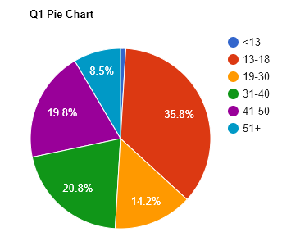

This shows that the largest group of people in the End User group are between the ages of 13-18. However, there is still a large chunk of people in most other age groups (apart from < 13 and 51+ age groups). This gives us an idea of our target audience.

*Question 2 - What would you describe yourself as?*

*Options:*

* A Novice Computer User
* An Intermediate Computer User
* An Advanced Computer User

*Number of people per option:*

**Novice -**  15 (14.2%)

**Intermediate** - 58 (54.7%)

**Advanced** - 33 (31.1%)

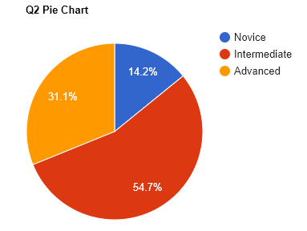

This shows that people within our end user group are a majority intermediate computer users. Therefore the installation process and options menu can be slightly more complex than that of a simpler game and slightly more simple than that of a complex game.

*Question 3 - How would you describe your computer’s overall speed/performance?*

*Options:*

* Low
* Mid-Range
* High

*Number of people per option:*

**Low -** 10 (9.4%)

**Midrange -** 59 (55.7%)

**High -** 37 (34.9%)

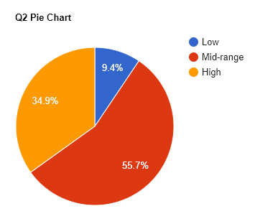

This data shows that the game we provide shouldn’t be too graphics intensive, as the majority of computers in the end-user group own a mid-range computer. Therefore, the game should be able to run on a mid-range computer.

*Question 4 - Have you ever played a 2-Dimensional platforming game before? (E.g. Mario, Donkey Kong, Manic Miner, Mega Man, Sonic, Thomas Was Alone etc.)*

Options:

* Yes
* No
* I don’t know

*Number of people per option:*

**Yes -** 103 (97.2%)

**No -** 2 (1.9%)

**I don’t know** - 1 (0.9%)

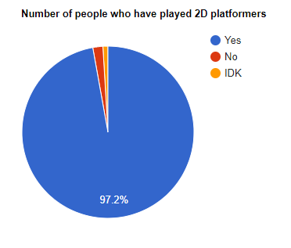

This data shows that almost everyone in the end user group has played the 2D platformer genre. This means that we are able to make the tutorial relatively simple as the user base has already experienced the general controls before.

*Question 5 - If so, what would you describe as the most appealing aspect of this genre? (Pick up to three options)*

Options:

* The Puzzles - I enjoy figuring out how to overcome obstacles
* The Enemies - I enjoy defeating enemies
* The Story - I enjoy a compelling plot
* The Art - I enjoy the art style of 2D platformer games
* Other… (Specify)

*Number of people who picked each option:*

**Puzzles -** 71 (36.4%)

**Enemies -** 31 (15.9%)

**Story -** 39 (20%)

**Art -** 38 (19.5%)

**Other -** 16 (8.2%)

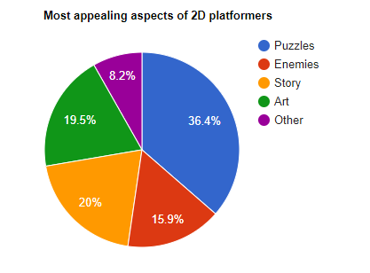

This shows that out of the defined options, puzzles are considered the most appealing. Therefore, throughout the creation of this game, we should focus on the puzzle aspect of the game.

*‘Other’ Comments:*

‘The movement’

‘Winning’

‘The emptiness after completion of the game so you can play again’

‘Everything’

‘The soundtrack’

‘The music’

‘The soundtrack, music and sound effects’

‘Mindless play’

‘Emotions’

‘Challenge to skills’

‘I enjoy the satisfaction of fast/effective traversal of stages’

‘Passes the time! (Not my favourite genre though)’

‘The pick up play-ability of the genre. ~It’s usually very obvious how to play the game. ~If it isn’t, it’s usually a badly made game’

‘The simplicity, the ‘pick up and play’ style and the inventiveness’

‘Mario is cute’

‘Ability to control people, god complex’

**Word cloud created from the ‘other’ comments, using** [**https://tagcrowd.com**](https://tagcrowd.com)

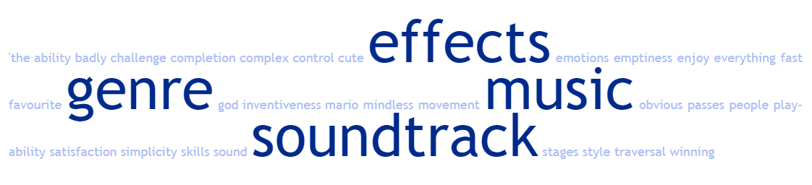

This word cloud shows that there is a frequency of comments concerning ‘effects’, ‘music’, ‘soundtrack’ and of course, genre. This means we may need to pay more attention to music and sound effects.

*Question 6 - What did you find least appealing about the genre?*

Options:

* The Puzzles - I dislike figuring out how to overcome obstacles
* The Enemies - I dislike having to defeat enemies
* The Story - I dislike a plotline
* The Art - I dislike the art style of 2D platformers
* Other… (Specify)

*Number of people who picked each option:*

**Puzzles -** 20

**Enemies -** 24

**Story -** 15

**Art -** 14

**Other -** 35

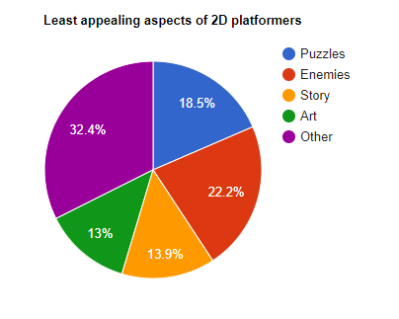

This shows that a large chunk of people dislike enemies in a game. This means that we may need to focus on client feedback throughout when designing the enemies in the game.

*‘Other’ comments:*

‘Gets repetitive’

‘Bad mechanics/gimmicks’

‘Moving things and taking jumps’

‘N/A’

‘N/A’

‘Nothing’

‘Nothing’

‘Nothing’

‘If it's just a genuinely bad game’

‘Bad 8 bit soundtracks’

‘Repetitive nature of some of the level design’

‘Basic’

‘First Person’

‘Single outcome’

‘Nothing’

‘Some levels are a bit boring but you have to do them to move onto next level’

‘I love all of these!’

‘Can’t always save progress’

‘Not being able to get to the end of the level’

‘Nothing’

‘Nothing specific!’

‘’

‘The camera angles’

‘Too many copy/paste games’

‘Being repetitive’

‘Pixel perfect precision to jumps’

‘Because game is 2D sometimes limited gameplay mechanics’

‘Levels not long enough’

‘Slow loading’

‘I don’t actually dislike anything there, but the story is least important to me’

‘Nothing’

‘A story used to explain the game and not part of the gameplay’

‘My inability to time jumps’

‘Compulsion to continue’

‘Reliance on mechanics that can be poorly implemented (e.g. wonky collision handling)’

‘Pixel perfect jumps’

**Word cloud created from the ‘other’ comments, using** [**https://tagcrowd.com**](https://tagcrowd.com)

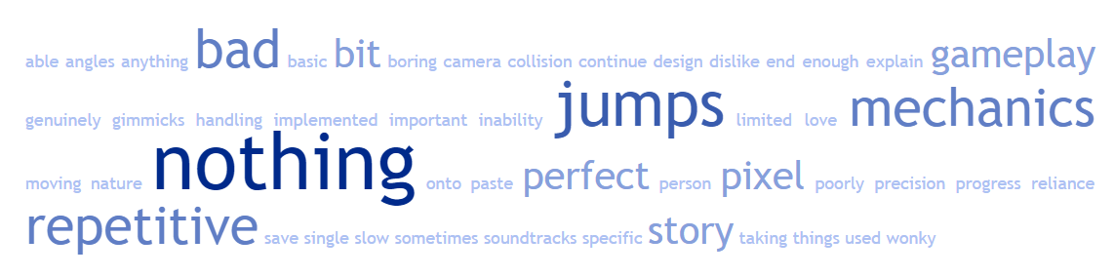

This shows that many people are concerned about the jumps, mechanics and repetitiveness of the game. Therefore we must focus on those three elements more, requesting client feedback throughout.

*Question 7 - If a new platformer were to come out would you prefer pixelated or drawn graphics?*

Options:

* Pixellated
* Drawn
* Other… (Specify)

*Number of people who picked each option:*

**Pixellated -** 39 (37.1%)

**Drawn** **-** 55 (52.4%)

**Other** - 11 (10.5%)

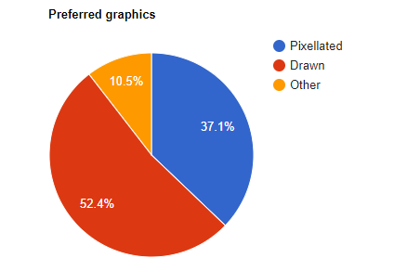

This shows that the overwhelming preference is for drawn graphics. This is most likely achievable as the software being used allows for both.

*‘Other’ comments:*

“Not bothered - would play!”

“VR”

“Depends on the plot”

“High standard CGI”

“Both”

“Don’t mind”

“I like both”

“Mixture of both”

“No preference”

“Vector line”

“Either”

“No preference”

Overall, these comments show that some people do not have a preference as to which type of graphics are used and others may want a combination of both drawn and pixelated graphics. There is still an overwhelming need for drawn graphics however so the project will be focused on that.

*Question 8 -Would you prefer the enemies in this platformer to be defeated simplistically (e.g: Jumping on enemies to defeat them) or with complexity (e.g: using certain items or actions)*

Options:

* Simplistic
* Complex

*Number of people who picked each option:*

**Simplistic -** 45 (42.5%)

**Complex** - 61 (57.5%)

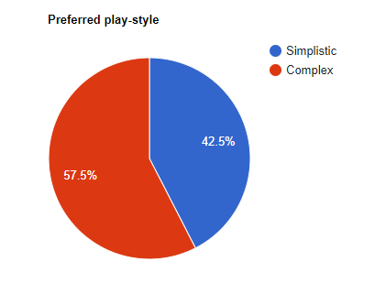

This shows that the preferred play style would be complex. Therefore there may also need to be an implementation of items or actions in order to cater to the end user audience.